Electronic Fetal Monitoring
Status Check

- J.W. is a 25 year old primigravida at 40 1/7 weeks gestational age, with an uncomplicated pregnan. Two hours ago, she was contracting every 4 minutes, her cervix was 3 cm dilated, completely effaced, and the fetal head was presenting at 0 Station. The nurse advises you that the patient thinks she’s just broken her water bag. As you enter her room to examine her, you notice the fetal monitor is showing a recent onset of variable decelerations with each contraction, dropping from 140 BPM to 90 BPM, and lasting twenty seconds, with moderate variability. Which of the following is the first thing you should do?
  - Sterile vaginal exam
  - Turn patient to her left side
  - Give oxygen
  - Give IV fluids
  - Give a tocolytic
- I.T. is a 17 year old woman at 38 0/7 weeks, undergoing induction of labor for severe pre-eclampsia. At 6 cm dilatation, she developed late decelerations, which were resolved with position change, oxygen at 2 L/min by nasal cannula, IV fluids, and stopping her oxytocin. After restoring the tracing to a Category I, the oxytocin was restarted at 1 mIU/min, but repetitive late decelerations returned, with minimal variability. She is still 6 cm dilated. Which of the following will most likely lead to the best outcome?
  - Tocolytics
  - Forceps
  - Cesarean Section
  - Stop the oxytocin, try again later
  - Increase oxygen delivery rate to 8 L/min

Write your interpretation of these three EFM Tracings

3.
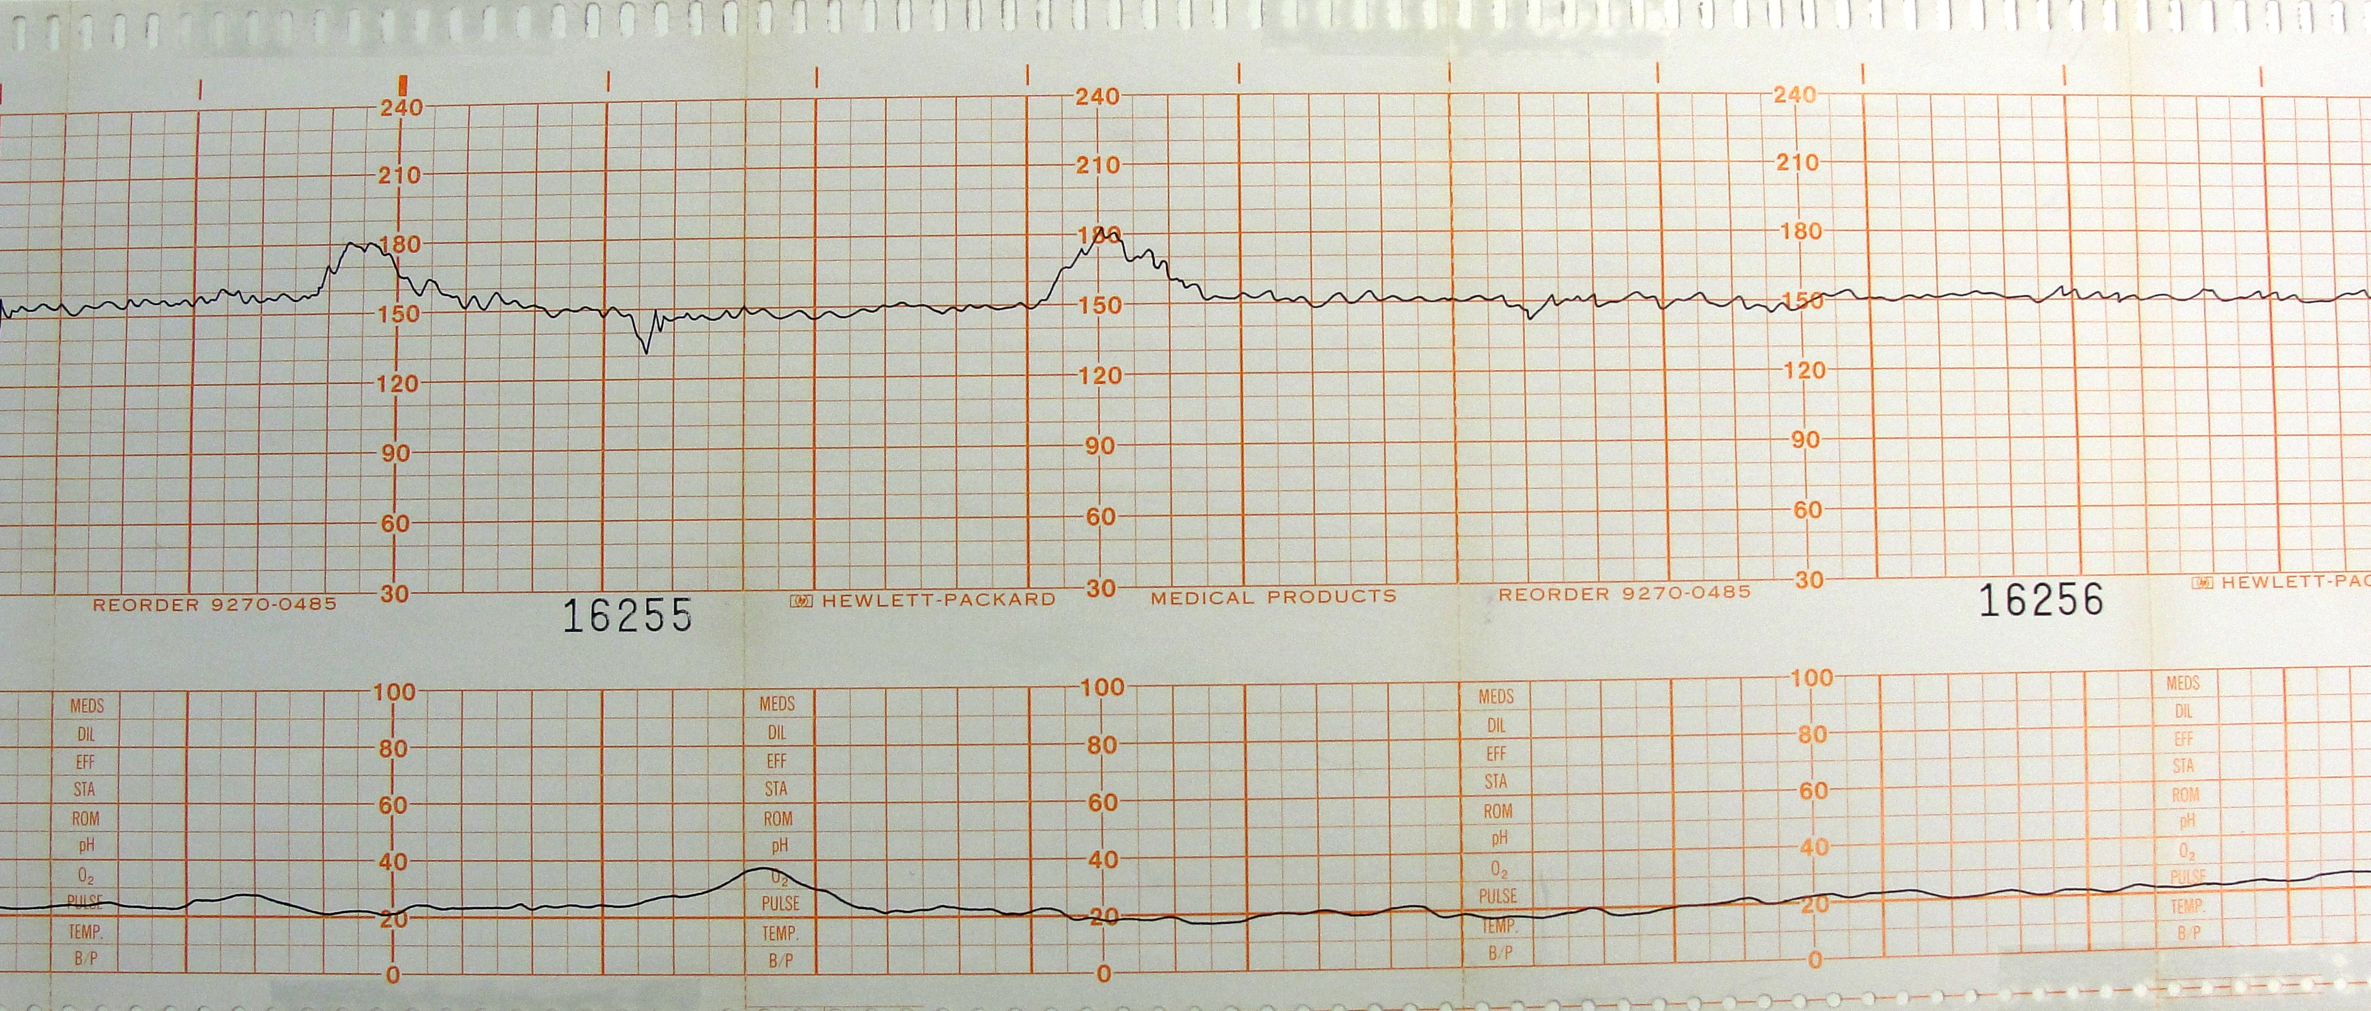

4.
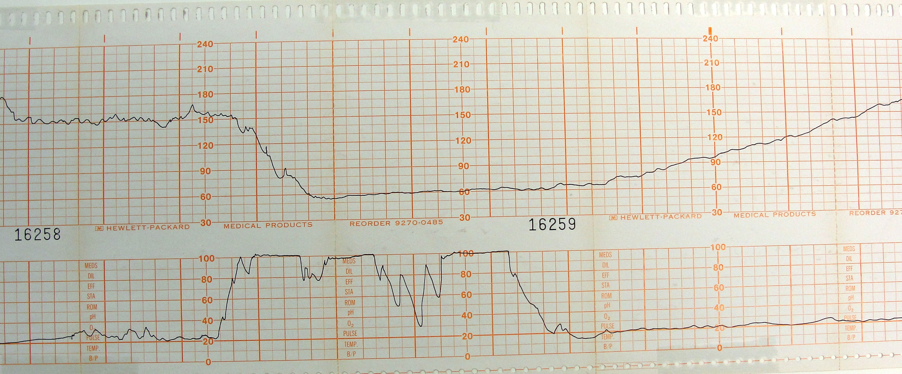

5.
